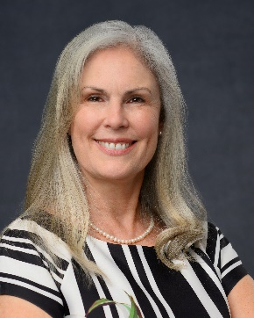
Marcia (Clark) Lucas, CFA is founder and president of Person-to-Person, a staff development company. Ms. Lucas launched Person-to-Person (P2P) after 12 years as a full-time lecturer in the finance department of California State University, Fullerton where she was recognized for excellence in teaching and service in 2017, 2019, 2020, and 2022 and received an Instructional Innovation Award from the CSUF College of Business and Economics in 2019. Ms. Lucas was awarded emeritus status with CSU Fullerton upon her retirement from full-time faculty in 2023.

Marcia’s career as a full-time educator is built on a 27-year foundation with the investment firm PIMCO and its parent company Allianz Global Investors (under her former name, Marcia Clark.) Her final assignment at AllianzGI was Global Director of the AllianzGI Academy where she developed professional education programs for client-facing staff in Allianz Global Investors’ regional offices in the U.S, Europe, and Asia Pacific.
Before retiring from CSU Fullerton in 2023, Professor Lucas served 8 years as director of the Titan Capital Management student investment program (TCM). During that time, students in the TCM program managed nearly $3.5 million for the philanthropic foundation of CSUF and regularly competed in CFA Institute student investment challenges. Prior to her time with TCM, Ms. Lucas served four years as director of the Business Honors program at CSU Fullerton.
To stay current with evolving investment practices, from 2015-2020 Ms. Lucas held a part-time position as senior research analyst for the private wealth management firm Warren Street Wealth Advisors (WSWA). In this role, she evaluated funds for WSWA investment strategies, developed a performance analysis system, prepared monthly market commentary (written, video, and blog), and delivered periodic client education events. During this time Marcia also worked with the Fixed Income Academy online education platform as lead instructor and course designer. In this role, she created training modules for industry practitioners and helped subject matter experts develop engaging training modules in their areas of expertise.

Ms. Lucas earned the Chartered Financial Analyst designation in 1999, and in 2001 was awarded a masters degree in business administration from the Anderson School of Management at UCLA.

Why P2P? During her time at CSUF, Marcia realized that her students were graduating with useful content in their brains but very little coaching on how to use that content effectively in the workplace. She founded Person-to-Person to help young professionals become more effective, enjoy higher job satisfaction, and improve retention. P2P courses include interpersonal skills training such as oral and written communication, versatility and conflict management, and supervisor coaching. P2P also offers classes in personal finance, investment essentials, financial modelling, and others.

